LJ POLYTECHNIC

A MINI PROJECT REPORT

ON

**Poll/Voting App**

(2024 - 2025)

Emerging Trends & Technologies

Submitted by:

|  |  |  |
| --- | --- | --- |
| **Sr. #** | **Enrollment #** | **Student Name** |
| 1 | 23012250210033 | Bhatt Rishi Chintankumar |
| 2 | 23012250210042 | Bhavsar Vraj Jignesh |
| 3 | 23012250210027 | Bhalara Krishita Dhaval |
| 4 | 23012250210066 | Dabhi Yuvraj NarendraSinh |
| 5 | 23012250210049 | Changela Jewel Uptalkumar |
| 6 | 23012250210036 | Bhavsar Dharmik Tanmaybhai |

**Problem statement explanation**

The Poll/Voting App aims to provide a simple and interactive platform where users can cast their votes and view results instantly. Traditional voting methods are slow and lack real-time feedback, while this system ensures immediate updates through a bar chart visualization. The app restricts users to one vote per session, maintains fairness, and displays accurate counts. With a responsive interface, it works efficiently on all devices, making polling easy, transparent, and engaging.

**Introduction**

Voting and polling are essential tools for gathering opinions, making decisions, and promoting participation in various fields such as education, business, politics, and social communities. Traditional voting methods often face challenges like manual counting, delays in results, and lack of transparency. To overcome these issues, digital solutions are increasingly adopted. The Poll/Voting App is designed to provide a fast, reliable, and interactive voting system. It allows users to cast their vote for given options and instantly view results in the form of a real-time bar chart. The application ensures fairness by restricting users to one vote per session and provides a responsive interface that works seamlessly across desktops, tablets, and smartphones.

**POLLVOTINGAPP.JS**

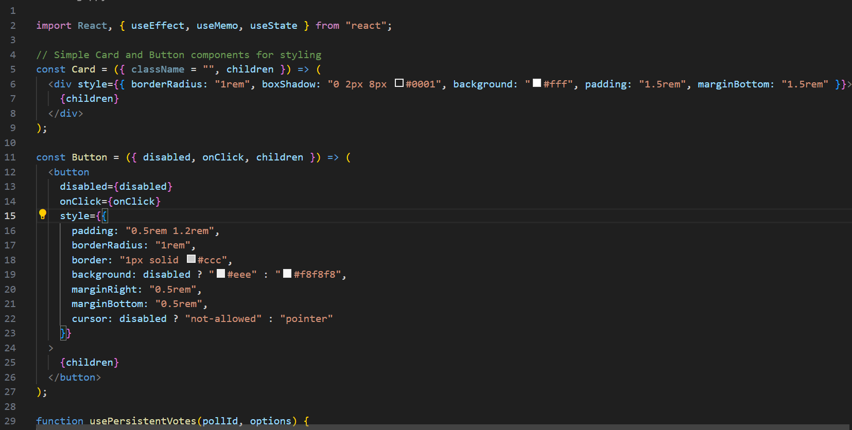

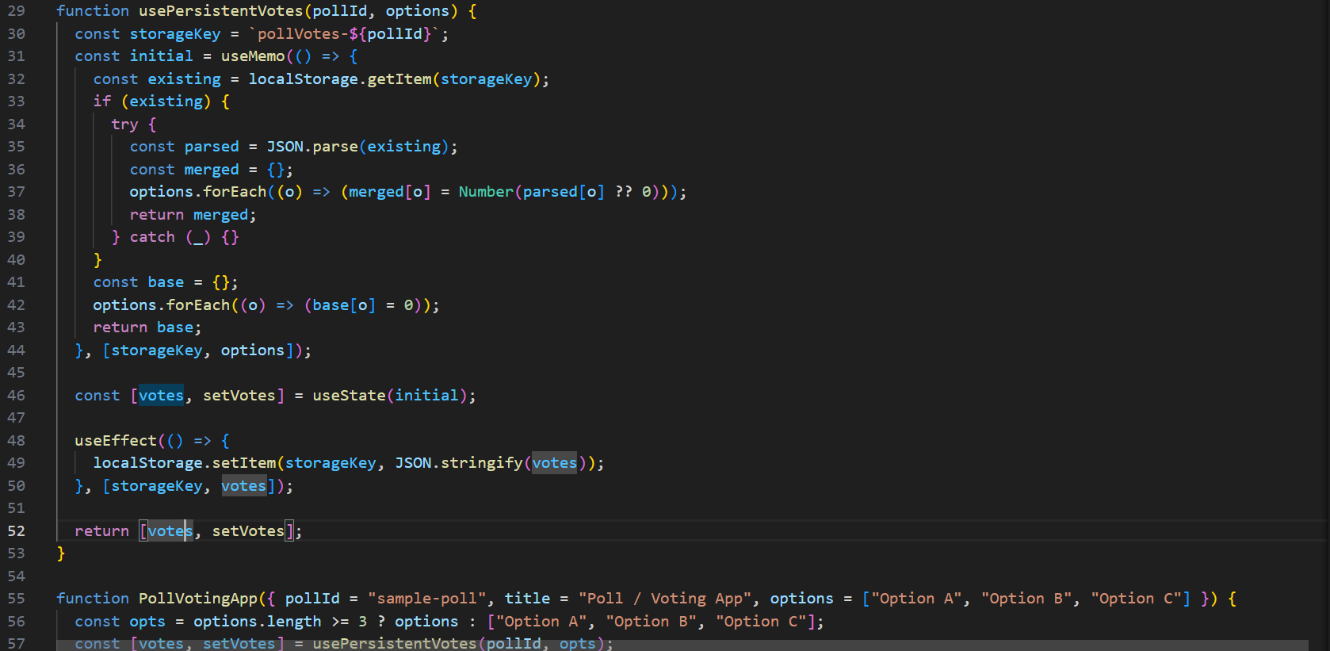

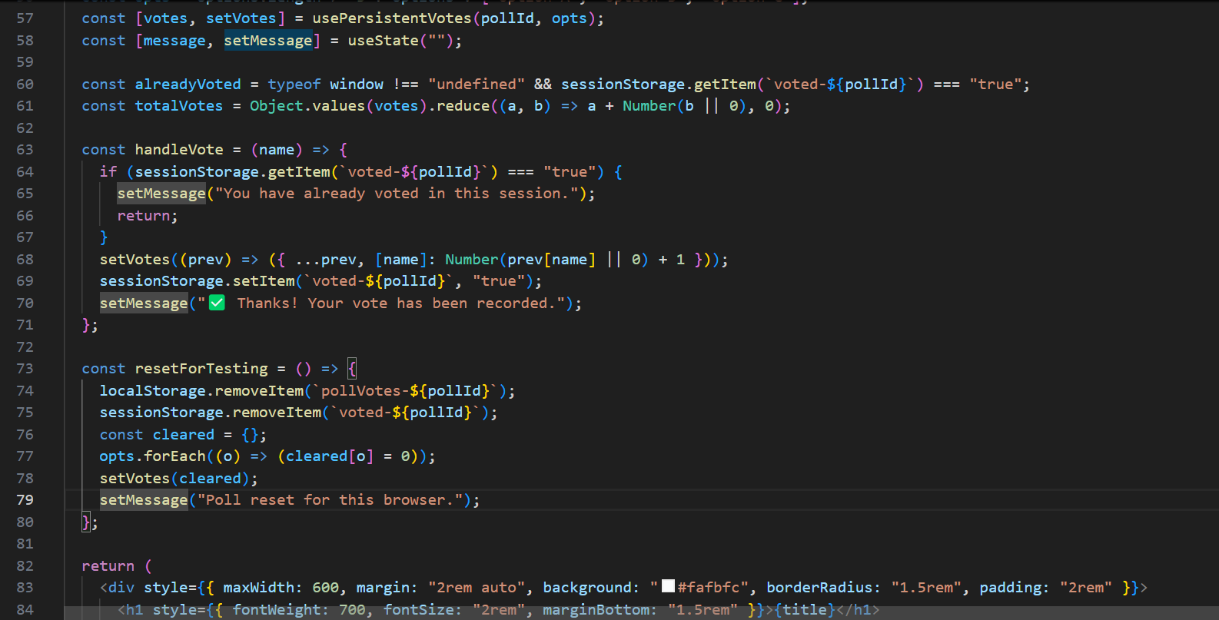

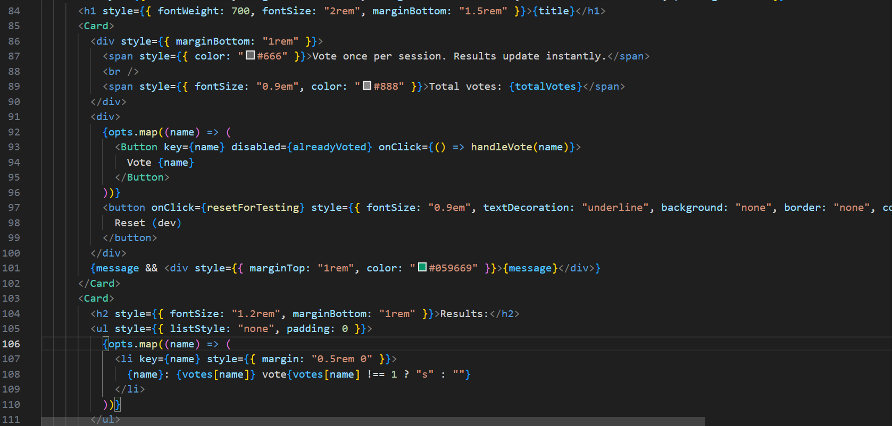

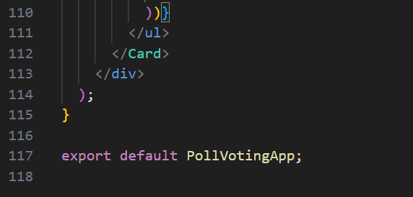

**OUTPUT**



